Andrew Bell, Nicholas Hinds, Andrew Terrado

CST 438 Group Project- Team 2

Kana Flights Database Design and Major Classes

**Overall Database Diagram**

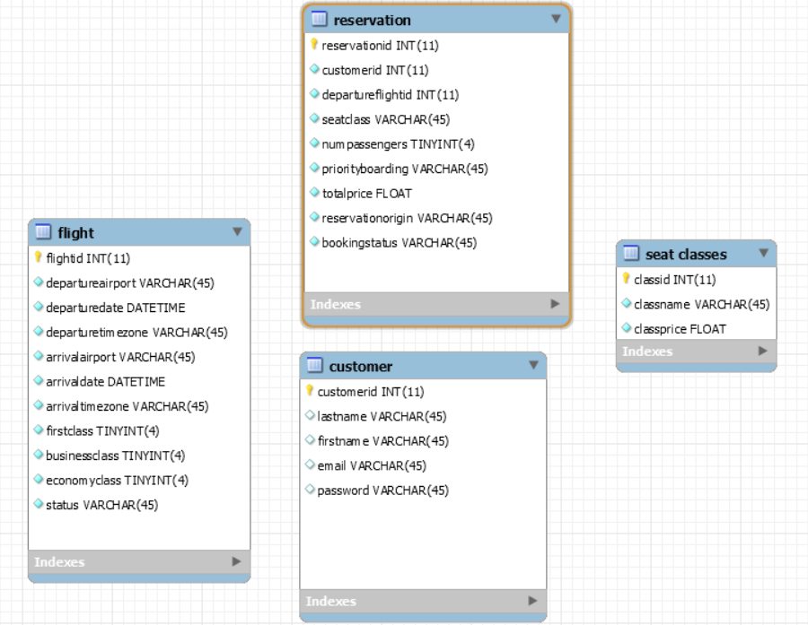

The database was designed to encapsulate core data into 4 distinct tables: flight, reservation, customer, and seat classes. Each table contains specific and mostly unique information, with minimal overlap to adjacent tables. This was done to keep the tables separate, organized, and provide an efficient and logical path to information. For added simplicity, our reservation table handles both the website and API generated reservations. In order to differentiate between the two reservation sources, the reservation origin is recorded.

**Database Breakdown**

**Flight**

*-This table contains information regarding all of our available flights. This includes airport locations, flight time, and available seating capacities*

|  |  |  |
| --- | --- | --- |
|  | **Description** | **Example** |
| int flightid | Flight identification number | 1, 2, 3 |
| varhchar departureairport | Departure airport location | Monterey |
| DateTime departuredate | Date/time of departure | 2020-09-01 20:00:00 |
| varhchar departuretimezone | Time zone of departure airport | PST |
| varhchar arrivalairport | Destination airport location | San Diego |
| DateTime arrivaldate | Date/time of arrival | 2020-09-01 20:00:00 |
| varhchar arrivaltimezone | Time zone of destination airport | HST |
| tinyint firstclass | First Class Seat Capacity | 1,2,3, etc. |
| tinyint businessclass | Business Class Seat Capacity | 1,2,3, etc. |
| tinyint economyclass | Economy Class Seat Capacity | 1,2,3, etc. |
| varchar status | Status of flight | On-time, delayed |

**ie:**



**Customer**

*-The Customer table contains user information, such as name, email, and password.*

|  |  |  |
| --- | --- | --- |
|  | **Description** | **Example** |
| int customerid | Customer identification number | 1,2,3 |
| varhchar lastname | Customer last name | Rey |
| varhchar firstname | Customer first name | Monte |
| varhchar email | Customer email address | kana@kana.com |
| varhchar password | Customer password | otterotter |

**ie:** 

**Reservation**

*-The reservation table contains entries for booked reservations. This table includes total price, number of passengers, etc. It references the flight and customer tables though the flightid and customerid respectively.*

|  |  |  |
| --- | --- | --- |
|  | **Description** | **Example** |
| int reservationid | Reservation identification number | 1, 2, 3 |
| int customerid | Customer identification number | 1, 2, 3 |
| int departureflightid | Flight identification number | 1, 2, 3 |
| varchar seatclass | Seating class for reservation | first, business |
| Tinyint numpassengers | Number of passengers booked | 1, 2, 3 |
| varchar priorityboarding | Priority boarding status | yes, no |
| Float totalprice | Total price of reservation | 300, 400 |
| varchar reservationorigin | Origin of reservation(site vs API) | kana, planner |
| varchar bookingstatus | Status of reservation | confirmed, cancelled |

**ie:**



**Seat Classes**

*-Planned to be used for data validation. It contains seat class names and prices.*

|  |  |  |
| --- | --- | --- |
|  | Description | Example |
| int classid | Class identification number | 1, 2, 3 |
| varchar classname | Class name | first, economy, business |
| Float classprice | Price for a seat in certain class | 100, 200, 300 |

**ie:**

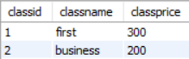

**Major Classes and Components**

**FlightService Class**

-Responsible for searching for available flights and booking new reservations

**Methods**

*public List<Flight> getFlightInfoArrival(String arrivalairport)*

-Takes destination airport string and returns list of all flights that feature the given destination

*public List<Flight> getFlightInfoDeparture(String departureairport)*

-Takes departure airport string and returns list of all flights that feature the given departure airport

*public List<Flight> getAvailableFights(String departureAirport, String arrivalAirport, String dateStr)*

-Takes departure airport, arrival airport, and date of flight, returns a list of flights that match the parameter.

*public Reservation requestReservation(String email, String seatClass, int numPassengers, boolean priorityBoarding, String origin, int flightID)*

-Takes email, seat class, number of passengers, boolean of priority boarding, origin of reservation, and the flight ID. Creates a reservation entry with given parameters and a new customer entry if the email is not in the database.

**CustomerService Class**

-Responsible for finding previous reservation information. Also allows users to cancel flights.

**Methods**

*public List<FlightInfo> getPreviousFlights(String email)*

-Takes a user’s email and creates a list of flights that the user has reservations associated with

*public List<ReservationFlightInfo> getPreviousReservations(String email)*

*public List<ReservationFlightInfo> getPreviousReservationsRest(String email)*

-Standard and Rest version. This takes the user’s email and generates a special data list that contains information about a user’s reservations and the flight associated with the reservation. Separate versions to prevent API from accessing non-planner reservations.

*public void updateStatus(String flightToCancel)*

*public void updateStatusRest(String flightToCancel)*

-Standard and rest version. Takes user reservationID, ie: flightToCancel. Finds flight by reservation number and changes its booking status to “cancelled”. Separate versions to prevent API from accessing Kana non-planner reservations.

**FlightRestController**

**Methods**

@GetMapping("/api/flights/arrival/{arrivalAirport}")

public ResponseEntity<List<Flight>> getFlightArrival(

@PathVariable("arrivalAirport") String arrivalAirport)

-Takes destination(arrival) airport string and returns a list of all flights going to this destination

@GetMapping("/api/flights/departure/{departureAirport}")

public ResponseEntity<List<Flight>> getFlightDeparture(

@PathVariable("departureAirport") String departureAirport)

-Takes departure airport string and returns a list of all flights leaving from this airport

@GetMapping("/api/flights/{departureAirport}/{arrivalAirport}")

public ResponseEntity<List<Flight>> getAvailableFlights(

@PathVariable("departureAirport") String departureAirport,

@PathVariable("arrivalAirport") String arrivalAirport,

String date

)

-Takes departure airport, destination airport, and date, and returns lists of flights that match the given parameters.

@GetMapping("/api/flights2/{departureAirport}/{arrivalAirport}/{month}/{day}/{year}")

public ResponseEntity<List<Flight>> getAvailableFlights(

@PathVariable("departureAirport") String departureAirport,

@PathVariable("arrivalAirport") String arrivalAirport,

@PathVariable("month") String month,

@PathVariable("day") String day,

@PathVariable("year") String year

)

-Takes departure airport, destination airport, month, day, and year. Returns lists of flights that match the given parameters.

@PostMapping("/api/flights")

public ResponseEntity<List<Flight>> getAvailableFlightsPost(

@RequestParam("departureAirport") String departureAirport,

@RequestParam("arrivalAirport") String arrivalAirport,

@RequestParam("date") String date

)

-Takes departure airport, destination airport, and date, and returns lists of flights that match the given parameters.

@PostMapping("/api/flight/reservation")

public ResponseEntity<Reservation> createReservation(

@RequestParam("email") String email,

@RequestParam("seatClass") String seatClass,

@RequestParam("numPassengers") int numPassengers,

@RequestParam("prioBoarding") boolean prioBoarding,

@RequestParam("flightID") int flightID

)

-Takes email, seat class, number of passengers, priority boarding status, flight ID number. Generates reservation entry in reservation database and records given parameters.

@GetMapping("/api/flight/reservation2/{email}/{seatClass}/{numPassengers}/{prioBoarding}/{flightID}")

public ResponseEntity<Reservation> createReservation2(

@PathVariable("email") String email,

@PathVariable("seatClass") String seatClass,

@PathVariable("numPassengers") int numPassengers,

@PathVariable("prioBoarding") boolean prioBoarding,

@PathVariable("flightID") int flightID

)

-Takes email, seat class, number of passengers, priority boarding status, flight ID number. Generates reservation entry in reservation database and records given parameters.

**CustomerRestController**

**Methods**

public ResponseEntity<List<FlightInfo>> getCustomerPreviousFlights(

@PathVariable("email") String email)

-Takes a user’s email and creates a list of flights that the user has reservations associated wit

public ResponseEntity<List<ReservationFlightInfo>> getCustomerPreviousReservationsRest(

@PathVariable("email") String email)

-Takes a user’s email and creates a list of the user's reservations.

public ResponseEntity<Reservation> cancelReservationRest(

@PathVariable("reservationID") Integer reservationID)

**Attached below is the API documentation that we provided to the other teams. It goes into much more detail about the API functionality and provides examples of expected outcomes.**

Andrew Bell, Nicholas Hinds, Andrew Terrado

CST 438 Group Project



Flights API Documentation (v3.03), 8/13/2020

Table of Contents

**API Summary** **9**

**Terms Reference Guide (JSON casing may differ)** **10**

**Searching Flights** **11**

Search For All Flights From A Specific Departure Airport 11

Search For All Flights To A Specific Destination Airport 11

Search For All Flights Between Two Locations (Departure to Destination)- Get/Post 12

Search Flights Between Two Locations (Departure to Destination:Specific Date)- Get/Post 13

**Booking Reservations** **14**

**Reviewing Booked Flight Information** **14**

**Cancelling Flights** **15**

Changelog (v3.03)

* Date implementation bug fix, revised successful output for getMapping (flight/date)

# **API Summary**

<https://kana-flight-service.herokuapp.com/>

**API Basic Workflow**

1. **Search for flights** with location names, date, etc. to get flight ID,count of seats available, etc.

2. **Book reservations** with email, seat class choice, passenger count, priority boarding status, and the flight ID. Return info includes reservationID

3. **Look up existing reservation** information with the user’s email address.

4. **Cancel flights** with the reservationID

**Need flight information?**

@GetMapping /api/flights/departure/{departureAirport}

@GetMapping /api/flights/arrival/{arrivalAirport}

@GetMapping /api/flights/{departureAirport}/{arrivalAirport}

@GetMapping /api/flights2/{departureAirport}/{arrivalAirport}/{month}/{day}/{year}

*Post Option*

@PostMapping("/api/flights")

@RequestParam("departureAirport")

@RequestParam("arrivalAirport")

@RequestParam("date")

**Need to book a reservation?**

@GetMapping /api/flight/reservation2/{email}/{seatClass}/{numPassengers}/{prioBoarding}/{flightID}

*Post Option*

@PostMapping("/api/flight/reservation")

@RequestParam("email")

@RequestParam("seatClass")

@RequestParam("numPassengers")

@RequestParam("prioBoarding")

@RequestParam("flightID")

**Need to look up a reservation?**

@GetMapping /api/previous_reservation/{email}

**Need to cancel a reservation**?

@GetMapping**:** api/cancel_reservation/{reservationID}

***Database is populated with flights to and from each location. Flights are available on 9/1 to 9/3, 2020**

# **Terms Reference Guide (JSON casing may differ)**

|  |  |  |
| --- | --- | --- |
| **Term** | **Examples** | **Notes** |
| arrivalAirport | Monterey, Honolulu, San Diego | Destination airport |
| departureAirport | Monterey, Honolulu, San Diego | Departure airport |
| email | kana@kana.com | User email stored/will be stored on Kana database |
| seatClass | economy, business, first | Selected seat class |
| prioBoarding | true, false | Priority boarding status |
| flightID | 1, 2,3, etc | ID of flight |
| numPassengers | 1, 2, 3, etc. | Number of passengers booked |
| firstclass | 1, 2, 3, etc. | Number of available class seats |
| businessclass | 1, 2, 3, etc. | Number of available class seats |
| economyclass | 1, 2, 3, etc. | Number of available class seats |
| reservationorigin | kana, planner | Origin of reservation |
| totalPrice | 1000.0, etc. | Total price of reservation |
| bookingStatus | Confirmed, cancelled | Status of reservation |
| status | on time, delayed | Status of flight |
| customerid | 1, 2, 3, etc. | Customer ID in Kana database |
| reservationid | 1, 2, 3, etc. | Reservation ID in Kana database |
| month | 09, 10, 11, etc. | Numeric representation: month |
| day | 01, 02, 03, etc. | Numeric representation: day |
| year | 2020 | Numeric representation: year |
| date | 09/01/2020 | Numeric representation: date |

**Pricing Reference Guide (Pricing handled automatically by Kana services)**

First- $300, Business- $200, economy- $100. Priority Boarding- $100 per passenger

# **Searching Flights**

* **flightid will be necessary for the reservation booking process**

## **Search For All Flights From A Specific Departure Airport**

@GetMapping /api/flights/departure/{departureAirport}

ie: /api/flights/departure/San Diego

Successful Output Example:

{

"flightid": 5,

"departureairport": "San Diego",

"arrivalairport": "Honolulu",

"departuredate": "2020-09-01T15:00:00.000+00:00",

"firstclass": 0,

"businessclass": 30,

"economyclass": 40,

"status": "on time"

},

{

"flightid": 6,

"departureairport": "San Diego",

"arrivalairport": "Monterey",

"departuredate": "2020-09-01T17:00:00.000+00:00",

"firstclass": 10,

"businessclass": 19,

"economyclass": 30,

"status": "on time"

},

Potential Causes For Unsuccessful Output:

* Incorrect input

Unsuccessful Output Example:

*(empty null response)*

## **Search For All Flights To A Specific Destination Airport**

@GetMapping /api/flights/arrival/{arrivalAirport}

ie: /api/flights/arrival/Monterey

Successful Output Example

"flightid": 1,

"departureairport": "Honolulu",

"arrivalairport": "Monterey",

"departuredate": "2020-09-01T15:00:00.000+00:00",

"firstclass": 0,

"businessclass": 30,

"economyclass": 40,

"status": "on time"

},

{

"flightid": 3,

"departureairport": "Honolulu",

"arrivalairport": "Monterey",

"departuredate": "2020-09-01T19:00:00.000+00:00",

"firstclass": 5,

"businessclass": 10,

"economyclass": 20,

"status": "on time"

},

Potential Causes For Unsuccessful Output:

* Incorrect input

Unsuccessful Output Example:

*(empty null response)*

## **Search For All Flights Between Two Locations (Departure to Destination)- Get/Post**

@GetMapping /api/flights/{departureAirport}/{arrivalAirport}

ie: /api/flights/Honolulu/Monterey

Successful Output Example:

[

{

"flightid": 1,

"departureairport": "Honolulu",

"arrivalairport": "Monterey",

"departuredate": "2020-09-01T15:00:00.000+00:00",

"firstclass": 0,

"businessclass": 30,

"economyclass": 40,

"status": "on time"

},

{

"flightid": 3,

"departureairport": "Honolulu",

"arrivalairport": "Monterey",

"departuredate": "2020-09-01T19:00:00.000+00:00",

"firstclass": 5,

"businessclass": 10,

"economyclass": 20,

"status": "on time"

}

]

Potential Causes For Unsuccessful Output:

* Incorrect input

Unsuccessful Output Example:

[ ]

***Post Option***

* ***Deprecated: For current version of this postMapping with date parameter, see next page***
* ***This version of the mapping is still functional***

@PostMapping("/api/flights")

@RequestParam("departureAirport")

@RequestParam("arrivalAirport")

# 

## **Search Flights Between Two Locations (Departure to Destination:Specific Date)- Get/Post**

* getMapping date is separated into month, day, and year path variables

@GetMapping /api/flights2/{departureAirport}/{arrivalAirport}/{month}/{day}/{year}

ie: /api/flights2/Honolulu/San Diego/09/01/2020

Successful Output Example:

[

{

"flightid": 2,

"departureairport": "Honolulu",

"arrivalairport": "San Diego",

"departuredate": "2020-09-01T17:00:00.000+00:00",

"firstclass": 10,

"businessclass": 20,

"economyclass": 30,

"status": "on time"

},

{

"flightid": 4,

"departureairport": "Honolulu",

"arrivalairport": "San Diego",

"departuredate": "2020-09-01T21:00:00.000+00:00",

"firstclass": 0,

"businessclass": 5,

"economyclass": 15,

"status": "on time"

}

]

Potential Causes For Unsuccessful Output:

* Incorrect input

Unsuccessful Output Example:

[ ]

***Post Mapping Option***

* postMapping uses a conventional date string, ie: “09/01/2020”

@PostMapping("/api/flights")

@RequestParam("departureAirport")

@RequestParam("arrivalAirport")

@RequestParam("date")

# **Booking Reservations**

* **flightid will be necessary for the reservation booking process**

**Book Reservation - Get or Post Options**

@GetMapping /api/flight/reservation2/{email}/{seatClass}/{numPassengers}/{prioBoarding}/{flightID}

ie: /api/flight/reservation2/bill@microsoft.com/first/20/true/1

Successful Output Example:

{

"reservationid": 15,

"customerid": 1,

"departureflightid": 1,

"seatclass": "first",

"numpassengers": 20,

"priorityboarding": "yes",

"totalprice": 8000.0,

"reservationorigin": "planner",

"bookingStatus": "confirmed"

}

Potential Causes For Unsuccessful Output:

* Too many seats booked
* Incorrect input

Unsuccessful Output Example :

"timestamp": "2020-08-11T20:17:31.015+00:00",

"status": 500,

"error": "Internal Server Error",

***Post Mapping Option***

@PostMapping("/api/flight/reservation")

@RequestParam("email")

@RequestParam("seatClass")

@RequestParam("numPassengers")

@RequestParam("prioBoarding")

@RequestParam("flightID")

# **Reviewing Booked Flight Information**

* Shows active reservations that have not been cancelled
* Only shows reservations booked by the travel planner
* Returns reservation information

@GetMapping /api/previous_reservation/{email}

ie: api/previous_reservation/bill@microsoft.com

Successful Output Example:

[

{

"reservationId": 5,

"id": 11,

"departureAirport": "Monterey",

"arrivalAirport": "San Diego",

"departureDate": "2020-09-01T19:00:00.000+00:00",

"status": "on time",

"bookingStatus": "confirmed",

"reservationOrigin": "planner"

}

]

Potential Causes For Unsuccessful Output:

* Incorrect email input

Unsuccessful Output Example:

"timestamp": "2020-08-11T20:17:31.015+00:00",

"status": 500,

"error": "Internal Server Error

# **Cancelling Flights**

@GetMapping**:** api/cancel_reservation/{reservationID}

ie: api/cancel_reservation/

Successful Output Example (bookingStatus changed to cancelled)

{

"reservationid": 5,

"customerid": 1,

"departureflightid": 11,

"seatclass": "economy",

"numpassengers": 2,

"priorityboarding": "yes",

"totalprice": 600.0,

"reservationorigin": "planner",

"bookingStatus": "cancelled"

}

Potential Causes For Unsuccessful Output:

* Incorrect email input
* Planner does not have access to a reservation (ie: reservations booked on Kana site)

Unsuccessful Output Example:

*(empty null response)*